

Bachelor of Science HES-SO in Telecommunications
Technologies de l’informationet de la communication

Classe T1A

Programmation & TP

- Travail Pratique -

S02 – Variables, types primitifs, opérateurs

Marc Roten

Haute école d’ingénierie et d’architecture de Fribourg (HEIA-FR)

HES-SO//Fribourg, 24 Septembre 2017

EX1

Byte b =5 float f = 2.5F
Short s = 8 double d = 5.2
Int i = 9

Expression | Type | Valeur |  | Expression | Type | Valeur
d/2 | double | 2.6 |  | b*b | int | 25
s*4 | short | 32 |  | i^3 | int | 10
(b+s) > (5*f) | bool | true |  | i*4/12%6 | int | 3
i/4 + d | double | 7.2 |  | b<<2 | byte | 20
1./3 | int | 0 |  | s==5 | !false | bool | true
b&6 | byte | 4 |  | i++ | int | 10

EX2
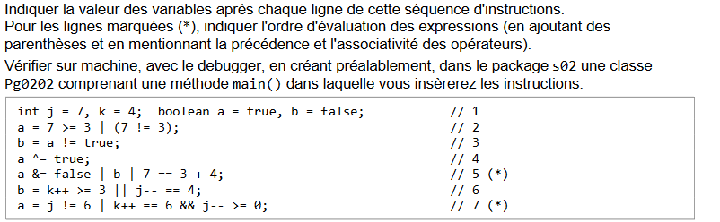
 | J | K | a | b
//1 | 7 | 4 | t | f
//2 | 7 | 4 | t | f
//3 | 7 | 4 | t | t
//4 | 7 | 4 | t | f
//5 | 7 | 4 | f | f
//6 | 7 | 4 | f | f
//7 | 7 | 5 | f | t

5*) a &=(false |b|( 7 ==(3 + 4)))
7*) a= (j !=6)|((k++)==6)&&((j--)>=0)

EX3
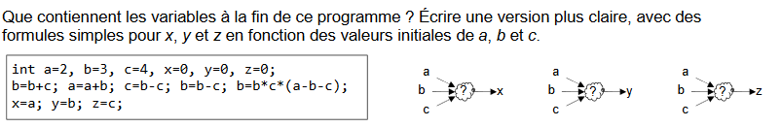
- b = b+c ; b=7
- a = a+b ; a = 9
- c = b-c ; c = 3
- b = b – c ; b=4
- b = b*C*(a-b-c) ; b = 4*3*(9-4-3)=24
  - x=9
  - y=24
  - z=3
➔x=a+b+c =2+3+4 = 9
➔y= a*b*c = 2*3*4 = 24
➔z= a+b-a = 3 + 4 – 2 = 5

EX4
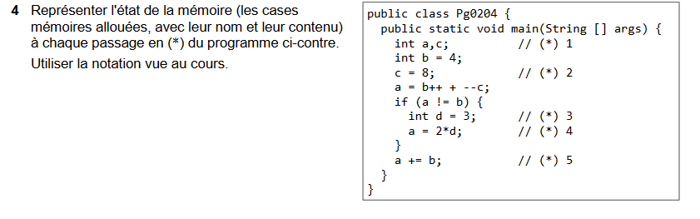
 | a | c
LINE 1
 | a | b | c
LINE 2 |  | 4 | 8
 | a | b | c | d
LINE 3 | 11 | 5 | 7 | 3
 | a | b | c | d
LINE 4 | 6 | 5 | 7 | 3
 | a | b | c
LINE 5 | 11 | 5 | 7

